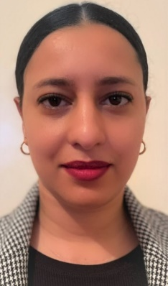
Meryem El haddaoui
19/12/1989
Email: elhaddaouimeryem_@gmail.com
Address: SECT 1NO 2157 HAY MY ISMAIL SALE
Phone: 212698990915
- Experiences
- 2020- 2022
- E-commerce: sale of women’s accessories BIJOUX BY MIRYAM
- April-2016 _ October-2018
- Customers receiving: Marina sale restaurant
Sale
- December-2014 _ july-2015
- School assistant: ALKALAM primary school
Agadir
- February-2013 - October-2014
    - Executive assistant: LYNAYA agency of tourist transport
Marrakech
- June-2011 – February-2013
    - Event hostess: IPS agency
Rabat
- Educations
- 2010: * bachelor of Arts:
      - Med Ben lhassan Elouazani
Sale
- 2012: * Business Management Technician
- Moroccan Institute of Professional and Technical Education
Rabat
- Skills
- Office Skills
- Communication
- Languages
- French, English, Arabic, german (beginner)

- Hobby
- Volunteer
- Teamwork
- Spirit of solidarity
- Yoga
- sing

